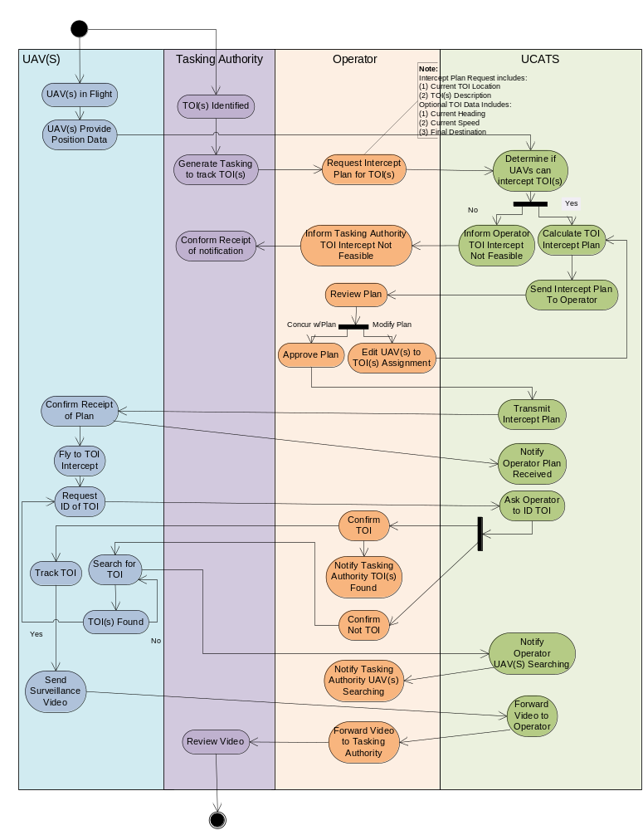Unmanned Tracking System-of-Systems Activity Diagram
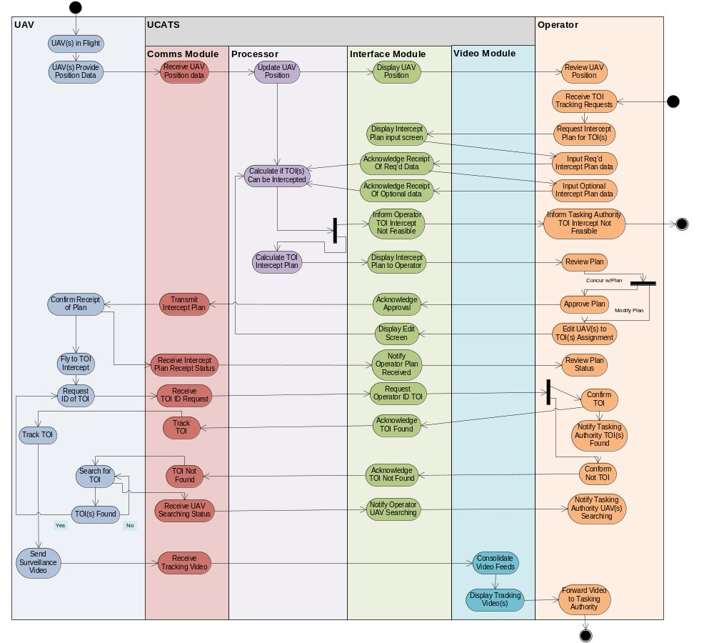
UCATS Activity Diagram

